Leaf Disease Detection Using CNN and Machine Learning

Harsh Thakur

UG Scholar, *Dept. of Electronics and Telecommunication Engineering*

*Shri shankaracharya institute of professional management and technology*

Raipur, India

[harsh.thakur@ssipmt.com](mailto:harsh.thakur@ssipmt.com)

Hemlata Sinha

Associate Professor, *Dept. of Electronics and Telecommunication Engineering*

*Shri shankaracharya institute of professional management and technology*

Raipur, India

[h.sinha@ssipmt.com](mailto:h.sinha@ssipmt.com)

**Abstract-The economy has a significant impact on agricultural productivity. The fact that plant diseases are highly prevalent in fields is one of the reasons for disease detection. The quality, quantity, or productivity of the corresponding product will be negatively impacted if good horticulture is not practiced in that particular location. The CNN method is utilized for image analysis in order to find the effects of the illness on the leaf. Agricultural goods can be improved by automatically detecting disease signs. It lowers the price of pesticides, insecticides, and other products, boosting agricultural output.**

***Keywords-Convolutional Neural Network, detection, image , disease.***

1. INTRODUCTION

In India, which has an agricultural economy, arable land makes up more than 54% of the country’s total land area? In terms of volume, India is one of the leading producers of rice, wheat, cotton, fruits, vegetables, and dairy products in the world. As our population increases, the demand for agricultural goods is increasing at a never-before-seen rate. A healthy diet ensures that the body receives all the vitamins, minerals, and nutrients it needs to function at its best. For optimal health, it's also crucial to maintain important vitamins and minerals. For the purpose of supplying food for the nutrias, agricultural diseases must be prevented and monitored. Because they may cause agricultural damage, which would reduce the chain of distribution and increase the cost of food.

Additionally, plant pests and illnesses can make food less palatable, forcing people to change their traditional eating choices. A soya bean illness known as "Sudden Death Syndrome" spread quickly across the United States (US) in 1970, eventually affecting all of the country's agricultural regions. Therefore, identifying crop leaf diseases with speed and accuracy puts the sustainability of agricultural production growth at risk.

"Let there be bread" is the Food and Agriculture Organization of the United Nations' (FAO) slogan.

Researchers and scientists have identified the main problems and difficulties [1, 2] when analyzing plant leaf diseases. Below are a few of them:

1. The leaf image must be of excellent quality.
2. Requirement for publicly accessible Datasets.
3. Uncertain data affecting leaf sample data.
4. Diseases can be detected by segmentation, but the sample needs to go through training.
5. Classification presents still another difficulty for the detection of leaf diseases.

A leaf disease detection method approaches for feature extraction, feature processing, picture segmentation, and machine learning. An automated disease detection system expedites the diagnostic procedure by giving the farmer an immediate and accurate diagnosis of the plant illness. To speed up crop diagnosis, the disease detection method must be automated. Image processing is the process of removing noise from photographs and enhancing their quality. Image processing is a discipline that is currently developing quickly. Examples of image processing include enhancement, segmentation, feature extraction, classification, and other methods. Making changes to an image's brightness, color temperature, noise reduction, and sharpness are all part of the improvement process.

* 1. LITRATURE SURVEY

A sample of the many ID techniques that may be applied to assess plant leaf disease is provided by Ghaiwat et al. The k- closest neighbor approach appears to be appropriate and the simplest class expectation algorithm for the provided test model. It might be challenging to choose the best SVM parameters when the information being prepared isn't immediately distinguishable [3].

According to Sanjay B [4], there are fundamentally four stages in the described handling plan, the first of which is the creation of a color change structure for the RGB picture input. Since RGB is used for shading age and changed or changed over RGB picture, for example HSI, is used for the recognizable proof of colors.

The limit value replaces the green pixels in the advancement that follows. Second, when the item is being portioned, the pre-registered limit amount of useful fragments that are initially ejected is used to separate the green pixels from the covering. The division is also completed in the fourth or last substantial progress.

The method for classifying and understanding the many diseases that affect plants is provided by Mrunalini et al. [5]. As it also saves energy, money, and time, a machine-made acknowledgement framework based on planning would prove to be quite beneficial for the Indian economy. The mechanism described in this for extracting the list of capabilities is known as the shading co-event technique.

In turn, infections in the leaves are distinguished via neural systems. Due to steam and root infections, the suggested arrangement will generally be an effective one that invests less effort in calculating.

It might significantly support precise leaf recognized evidence.

There are a few apportions, among which the following four significant advancements are according to the paper's [6] technique for identifying the disease: The information RGB image is first given a colour change structure, after which a certain edge value is used, green pixels are hidden and erased, linked by a division technique, and surface insights are established for the information RGB object. Useful sections. In the end, the classifier is used to distinguish the illness for the qualities eliminated. The suggested calculation's strength is demonstrated using test results obtained from a database of roughly 500 plant leaves.

By using a fake neural network (ANN) and several picture-preparation techniques, Kulkarni et al. demonstrate a quick and accurate method for finding plant diseases. In order to identify between different plant illnesses, an ANN-based classifier uses a combination of surfaces, shading, and qualities [7]. Because the arrangement is necessary for the suggested strategy.

Researchers use an effective method, such as K-mean bunching, surface, and shading analysis [8], to demonstrate disease identification in Malus domestica. For the most part appearing in traditional and affected zones, surface and shading characteristics are used in this to recognize and separate explicit farming. Over the next few days, Bayes

Classifier and essential element K-implies clustering will be performed using a classifier. [9]

According to the [10] histogram, the data is used to identify plant diseases. Infected leaves are visible in plants, thus a coordinated histogram is created based on the edge localization technique and shading characteristics. The preparation process employs a layers isolating technique that includes planning of these instances, which separate the layers of the RGB object into red, green, and blue layers, and an edge locating method, which identifies the edges of the layered objects. A co-happening structure is created

using spatial grey dependence matrices for surface .

The triangle's limit and the fundamental edge methods are presented by Sanjay B [11]. These methods are applied independently for lesions in the leaf zone and the field. By determining the remaining leaf region and the damage zone, the infection order is carried out in the final stage. According to the research, the technique is quick and accurate to determine the severity of the leaf infection, and the area of the plant is calculated using limit division.

To identify the computation for the disease area division in the yield leaf, creators utilize picture preparation techniques [12]. The disease spot recognizable proof approach is used in this study by comparing the effects of the shading spaces HSI, CIELAB, and YCbCr. To smear the image, the center channel is used. In the most recent advancement, by using the Otsu approach on the shade variable, an edge may be approximated to identify the disease location. The test result, the camera streak, and the vein all show some agitation from the foundation. It is eliminated by using the CIELAB shading model. The state of the workmanship audit of several methods for identifying leaf illnesses using picture-preparation systems is shown in the paper [13].

Existing technical ideas aim to increase throughput while reducing subjectivity brought on by unassisted eye perception that distinguishes and diagnoses plant diseases.

Disease of Plant Leaves: A Brief Overview The study by Kiran R. Gavhale and U. Gawande, Gavhale and Gawande (2014) used image processing techniques and presented surveys and condenses picture handling protocols for various plant species that have been used to recognize plant ailments. The neural back spreading system (BPNN), Sup Intelligent Wheat Diseases Diagnosis System reliant on Android Phone by Y. Q. Xia, Y. Li, and C. Li, [14] and other methods are the key methods for the recognition of plant illnesses.

Li, Xia, and Li (2015) proposed an application approach to assess cunning wheat infections in 2015. With the use of App devices, customers take pictures of wheat contamination and upload them to a system test database. After processing the illness images, the server executes object division by converting the RGB shading space of the images to the HSI shading field. The use of the shade minute framework and the dim will be used to manage the color and surface characteristics of the disorders.

Co-event grid at level. Contribution to the recognition vector support machine and customer feedback on the results of the recognized proof is the most popular features. [15]

Use of RGB and Gray Scale Images in Plant Leaf Disease Detection: Padmavathi and Thangadurai (2016) conducted a similar study that showed the relative impacts of RGB and Gray Scale Images in the process of identifying leaf diseases. When identifying sick leaves, shading is a key factor in determining the severity of the disease. To enhance the image and separate the segment needed to identify the severity of the illness, we combined images from Grayscale and RGB images together with a middle channel. Deep convolution systems were used to develop the model for the observable verification of plant diseases based on the

arrangement of leaf objects. Sound leaves that are capable of identifying leaves from the surroundings are known to contain 13 different types of diseases.

* 1. ARCHITECTURE



IMAGE SEGMENTATION

IMAGE PRE-PROCESSING



IMAGE ACQUISITION



STATISTICAL ANALYSIS

FEATURE EXTRACTION

CLASSIFICATION BASED ON CLASSIFIER

Fig 3.1 ARCHITECTURE OF DISEASED LEAF DETECTION

**METHODOLOGY**: In this section, we use a k-mean grouping computation to describe the expected of leaf disease. Various metrics for image acquisition, image preprocessing, feature extraction, and the neural system-based order are remembered in this study.

This proceeds as follows:

* Image Acquisition
* Image Preprocessing
* Image segmentation
* Feature extraction

**IMAGE ACQUISITION:**

In general, image acquisition in image processing refers to the activity of obtaining an image from a source, often one that is based on hardware, in order to transmit it through the subsequent processing steps. The initial stage in the workflow sequence for image processing is always picture capture since processing is impossible without an image. It can be crucial in some sectors to have a constant baseline from which to work, because the obtained image is entirely unprocessed and is the product of whatever apparatus was used to produce it. One of the ultimate aims of this approach is to have an input source that runs within such precise and regulated parameters that the same image can, if required, be nearly precisely duplicated under the same circumstances, making it simpler to identify and remove anomalous variables.

Depending on the industry, the initial configuration and ongoing maintenance of the gear used to collect the images might be a significant influence in image

acquisition and image processing. The hardware itself might range from a small desktop scanner to a huge optical telescope. Visual artifacts may result from improperly setup and aligned hardware, which will make image processing more challenging. Inadequately configured hardware may also produce photos of such poor quality that they cannot be saved despite intensive processing. All of these components are essential to some fields, such comparative image processing, which seeks for particular variations among picture collections.

**IMAGE PRE-PROCESSING:**

Before being utilized for model training and inference, pictures must first undergo image preprocessing. This includes, but is not limited to, adjustments to the size, orientation, and color.

Image augmentation is the process of altering photographs to produce many variations of the same subject matter in order to provide the model with a greater variety of training instances. For instance, randomly changing the orientation, brightness, or size of an input picture necessitates that a model take into account how the image subject can seem in various scenarios.

However, there is a crucial distinction between image augmentation and image preprocessing: although image preprocessing techniques are performed to both training and test sets, image augmentation is only applied to the training data. As a result, in certain circumstances, a change that would be an augmentation may be better as a pretreatment step.

Think about adjusting the visual contrast. Images with typically low contrast may be present in a dataset. The model's performance may be enhanced by mandating that each image undergo a constant amount of contrast adjustment if it will only be used in production on low contrast images in all scenarios. During training and testing, this preprocessing step would be done to pictures. There is less assurance that a continual contrast adjustment is necessary if the training data was not indicative of the levels of contrast the model may encounter in production. Instead, it could be more generalizing to randomly change the visual contrast during training. That is enhancement.

**IMAGE SEGMENTATION:**

Image segmentation is a technique for breaking up a digital image into smaller groupings called image segments, which reduces the complexity of the image and makes each segment more easily processed or analyzed. Technically, segmentation is the process of giving labels to pixels in a picture in order to distinguish between objects, persons, or other significant aspects.

Object detection is a frequent use of picture segmentation. It is usual practice to initially apply an image segmentation method to discover things of interest in the picture before processing the complete image. The object detector may then work with a bounding box that the segmentation algorithm has previously established. By stopping the detector from analyzing the full picture, accuracy is increased and inference time is decreased.

A crucial component of computer vision technologies and algorithms is image segmentation. It is employed in a variety of real-world contexts, including as face identification and recognition in video surveillance, medical image analysis, computer vision for autonomous cars, and satellite image analysis.

**FEATURE EXTRACTION:**

The technique of turning raw data into numerical features that can be handled while keeping the information in the original data set is known as feature extraction. Compared to using machine learning on the raw data directly, it produces superior outcomes.

It is possible to extract features manually or automatically:

1. Identification and description of the characteristics that are pertinent to a particular situation are necessary for manual feature extraction, as is the implementation of a method to extract those features. Having a solid grasp of the context or domain may often aid in making judgments about which characteristics could be helpful. Engineers and scientists have created feature extraction techniques for pictures, signals, and text through many years of research. The mean of a signal's window is an illustration of a straightforward characteristic.
2. Automated feature extraction eliminates the need for human involvement by automatically extracting features from signals or pictures using specialized algorithms or deep networks. When you need to go from collecting raw data to creating machine learning algorithms rapidly, this method may be quite helpful. An example of automated feature extraction is wavelet scattering.

**CO-OCCURRENCEMATRIX:**

The co-occurrence network depiction of surface trademark, which is R.M. Haralick's main method, discusses the shape's dim spatial power. A co- occurrence network has the following scientific meaning:

* Appointed as administrator P (i, j),
* Assume that A is a lattice with dimensions n x n, and that its component A[i][j] represents the occurrences of graylevel (power) focuses g[i] relative to dim level focuses g[j] at the location given by P.
* Let C be the n × n network obtained by dividing A by the total number of point sets satisfying P. C[i][j] is a percentage of the combined probability of obtaining values g[i], g[j] for a few points satisfying P.
* Let C be the n × n network obtained by dividing A by the total number of point sets satisfying P. C[i][j] is a percentage of the combined probability of obtaining values g[i], g[j] for a few points satisfying P.
* A P-characterized grid of co-events is known as C.

Administrator P can be modelled as "I above j" or "I one to one side and two under j," for example. This may also be described as chases... When a co-occurrence network is used for each graylevel (a, b) by [1], let t be an interpretation. A district's CT is distinguished by:

𝐶(𝑎, 𝑏) = 𝑐𝑎𝑟𝑑{(𝑠, 𝑠 + 𝑡) ∈𝑅2|𝐴[𝑠] = 𝑎, 𝐴[𝑠 + 𝑡] = 𝑏}

In this case, Ct(a, b) is the number of site couples, which is shown by (s, s+t) and recognized by an interpretation vector t, with a graylevel s and a dim level s+t, respectively.

**NN CLASSIFICATION:**

**CONVOLUTIONAL NEURAL NETWORKS:**

Neural networks are a subset of machine learning and are at the core of deep learning algorithms, as was stated in the Neural Networks Learn Hub page. They are made up of node levels, each of which includes an input layer, one or more hidden layers, and an output layer. Each node has a threshold and weight that are connected to one another. Any node whose output exceeds the defined threshold value is activated and begins providing data to the network's uppermost layer. Otherwise, no data is sent to the network's next tier.

There are other kinds of neural nets, which are utilized for diverse use cases and data sources, while we mainly concentrated on feed forward networks in that article. Recurrent neural networks, for instance, are frequently used for speech and natural language processing, but convolutional neural networks (also known as CNNs or ConvNets) are more frequently employed for classification and computer vision applications. Before CNNs, identifying objects in pictures required the use of laborious, manual feature extraction techniques. Convolutional neural networks, on the other hand, now offer a more scalable method for classifying images and recognizing objects by using matrix multiplication and other concepts from linear algebra to find patterns in images. However, they can be computationally taxing, necessitating the use of graphics processing units (GPUs) when modeling them.

**ARCHITECTURE OF A CNN:**

1. Feature extraction is a procedure that uses a convolution tool to separate and identify the distinct characteristics of a picture for study.
2. There are several pairs of convolutional or pooling layers in the feature extraction network.
3. A fully connected layer that makes use of the convolutional process's output and determines the class of the picture using the features that were previously extracted.
4. This CNN feature extraction model seeks to minimize the quantity of features in a dataset. It generates new features that compile an initial set of features' existing features into a single new feature. As seen in the CNN architectural diagram, there are several CNN levels.

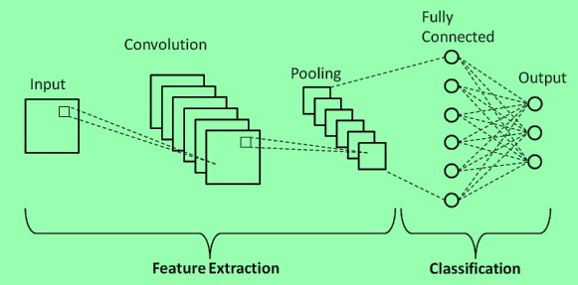

FIG3.2 CNN ARCHITECTURE

* 1. **TECHNOLOGIES:**

**Python:** Python is an interpreted, object-oriented, high-level, dynamically semantic programming language. It is particularly desirable for Rapid Application Development as well as for usage as a scripting or glue language to tie existing components together due to its high-level built-in data structures, dynamic typing, and dynamic binding. Python's straightforward syntax prioritises readability and makes it simple to learn, which lowers the cost of programme maintenance. Python's support for modules and packages promotes the modularity and reuse of code in programmes. For all popular systems, the Python interpreter and the comprehensive standard library are freely distributable and accessible in source or binary form.

Python programs are simple to debug since a segmentation failure is never caused by a bug or incorrect input. Instead, the interpreter raises an exception when it finds a mistake. The interpreter produces a stack trace if the application doesn't catch the exception. Setting breakpoints, evaluating arbitrary expressions, inspecting local and global variables, stepping through the code one line at a time, and other features are all possible with a source level debugger. Python's ability to do introspection is demonstrated by the debugger, which is developed in Python

* 1. **EXPECTED RESULTS:**

**Input Image:**

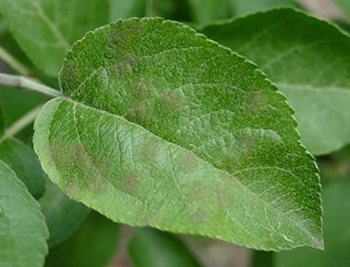

FIG 5.1 IMAGE OF APPLE LEAF

**Output Image:**

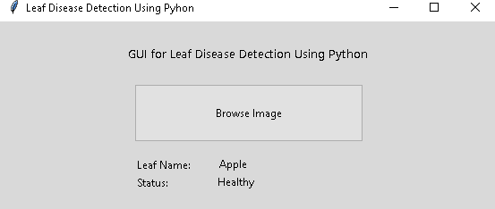

FIG 5.2 OUTPUT OF HEALTHY APPLE LEAF

**Input Image:**

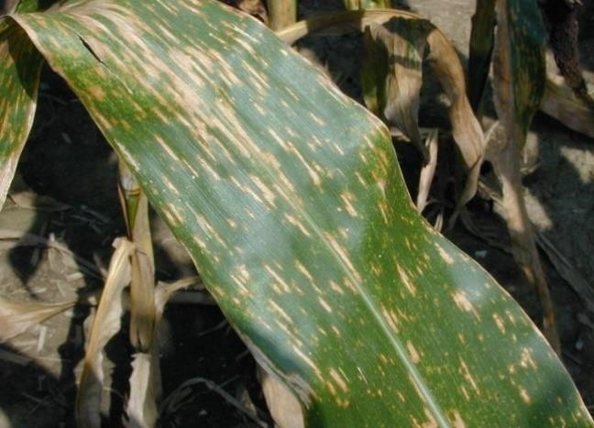

FIG 5.3 IMAGE OF CORN (MAIZE) LEAF

**Output Image:**

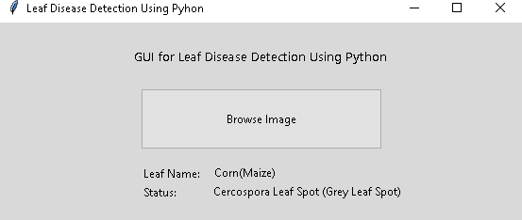

FIG 5.4 OUTPUT OF DISEASE CERCOSPORIA LEAF

* 1. CONCLUSION:

Image processing may be used to accurately identify and classify plant diseases, which is crucial for efficient agricultural production. This study examined several methods for classifying the disease's plant component. This research also discussed several methods for identifying diseased leaf characteristics and categorizing plant diseases. Here, we employ a Convolution Neural Network (CNN), which has a number of layers employed for prediction. The entire procedure was described, starting with the collection of pictures used for training and testing, moving on to image preprocessing and enhancement, followed by the deep CNN training approach and optimization. These image processing techniques enable us to recognize and classify various plant diseases with accuracy.

* 1. **REFERENCES:**

[1] [Chaitali G Dhaware, K H Wanjale, A modern](http://refhub.elsevier.com/S2666-285X(22)00021-8/sbref0001) [approach for plant leaf disease classi-ﬁcation](http://refhub.elsevier.com/S2666-285X(22)00021-8/sbref0001) [which depends on leaf image processing, in: IEEE](http://refhub.elsevier.com/S2666-285X(22)00021-8/sbref0010) [International](http://refhub.elsevier.com/S2666-285X(22)00021-8/sbref0010)

[ConferenceonComputerCommunicationandInform](http://refhub.elsevier.com/S2666-285X(22)00021-8/sbref0010) [atics,2017,pp.12–16.](http://refhub.elsevier.com/S2666-285X(22)00021-8/sbref0010)

[[2]J.P.Nayak,K.Anitha,B.D.Parameshachari,R.Banu](http://refhub.elsevier.com/S2666-285X(22)00021-8/sbref0001)

[,P.Rashmi,PCBFaultdetectionusing Image](http://refhub.elsevier.com/S2666-285X(22)00021-8/sbref0001) [processing, IOP Conference Series: Materials](http://refhub.elsevier.com/S2666-285X(22)00021-8/sbref0011) [Science and Engineering,225,IOPPublishing,2017.](http://refhub.elsevier.com/S2666-285X(22)00021-8/sbref0011)

1. SavitaN.Ghaiwatetal.,Detection and classification of plant leaf diseases using image processing techniques :a review(2014).
2. Prof.SanjayB.etal.,Agriculturalplantleafdiseasedet ectionusingimageprocessing(2013).
3. Mrunalini R. et al., An application of K- meansclusteringandartificialintelligenceinpatternreco gnitionforcropdiseases(2011)

[6]S.Arivazhaganetal., Detection of unhealthy region of plant leaves and classification of plant leaf diseases using texture features(2013)

1. AnandH.Kulkarnietal.,Applying image processing technique to detect plant diseases(2012)
2. Sabah Bashir et al., Remote area plant disease detection using image processing (2012)
3. Smita Naikwadietal., Advances in image processing for detection of plant diseases(2013).
4. SanjayB.Patiletal., Leaf disease severity measurement using image processing (2011)
5. Piyush Chaudhary et al., Color transform based approach for disease spot detection on plant leaf(2012)
6. ArtiN.Rathodetal.,Image processing techniques for detection of leafdisease(2013)
7. KiranR.Gavhale,andU.Gawande,“AnOverviewoftheRe searchonPlantLeavesDiseasedetectionusingImageProcessin gTechniques,”IOSRJ.ofCompu.Eng.(IOSRJCE),vol.16, PP10-16,Jan. 2014.

[14]Y.Q.Xia,Y.Li,andC.Li,“ Intelligent Diagnose System of Wheat Diseases Based on Android Phone,” J. of Infor. & Compu. Sci., vol.12,pp. 6845-6852, Dec.2015.

[15]K.Padmavathi,andK.Thangadurai,“Implementation of RGB and Gray scale images in plant leaves disease detection–comparative study,” Indian J. of Sci. and Tech., vol. 9, pp. 1-6,Feb.2016.